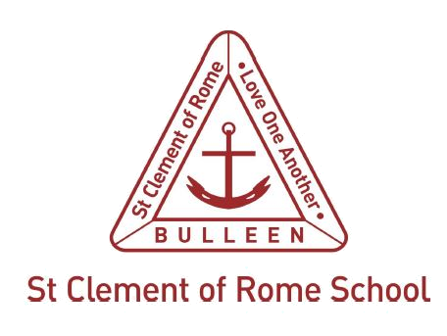

Related Resources

St Clement of Rome Catholic Primary School policies

- Informing staff about mandatory reporting obligations
- St Clement of Rome Catholic Primary Child Safety Policy
- St Clement of Rome Catholic Primary Reportable Conduct Policy
- St Clement of Rome Catholic Primary Child Safety Code of Conduct
- St Clement of Rome Catholic Primary Principle of Inclusion Guidelines

Melbourne Archdiocese Catholic Schools (MACS)
- PROTECT: Identifying and Responding to All Forms of Abuse in Victorian Schools
- Four Critical Actions for Schools: Responding to Incidents, Disclosures and Suspicions of Child Abuse
- PROTECT: Responding to Suspected Child Abuse: A Template for all Victorian Schools
- School Guidelines 2.19a: Police and DHHS Interview Protocols
- Catholic Schools Operational Guide (CEVN website)
- Privacy Compliance Manual (CEVN website):
- updated by the Catholic Education Commission of Victoria Ltd (CECV) February 2020
- may be used by schools and systems which are represented by the CECV
- Family and Domestic Violence: A guide to supporting staff (CECV 2019)

Counselling and support resources
- Daniel Morcombe Child Safety Curriculum
- Respectful Relationships
- The Lookout
- Safe Steps
- 1800RESPECT
- Centres Against Sexual Assault
- Gatehouse Centre, Royal Children’s Hospital
- Kids First
- Australian Childhood Foundation
- Djirra
- Child Wise
- headspace
- Victorian Aboriginal Child Care Agency (VACCA)

Department of Education and Training (DET)
- Policy and Advisory Library (PAL)
- Protecting Children eLearning module

Department of Health and Human Services (DHHS)
- Child Protection
- Child FIRST/The Orange Door

Department of Justice and Community Safety
- Failure to disclose offence
- Failure to protect offence
- Grooming offence
- Reportable conduct

Related legislation
- Children, Youth and Families Act 2005 (Vic.)
- Child Wellbeing and Safety Act 2005 (Vic.)
- Family Violence Protection Act 2008 (Vic.)
- Crimes Act 1958 (Vic.)
- Education and Training Reform Act 2006 (Vic.)
- Education and Training Reform Regulations 2017 (Vic.)
- Charter of Human Rights and Responsibilities Act 2006 (Vic.)

Commission for Children and Young People (CCYP)
- Reportable Conduct Scheme

Victorian Government
- Ministerial Order 870: Child Safe Standards – Managing the Risk of Child Abuse in Schools

Victoria Police
- Victoria Police Sexual Offences and Child Abuse Investigation Teams (SOCITs)

Further information
The MACS Student Wellbeing Information Line can be contacted between 9 am and 5 pm weekdays on 9267 0228.

The Student Wellbeing Information Line seeks to:
- address matters that impact the wellbeing and educational outcomes of young people arising in MACS school communities across the Archdiocese of Melbourne using a solution-focused framework
- act as a conduit between the school and family to promote effective communication and resolution of enquiries
- empower and enhance the capacity, competence and confidence of stakeholders to address matters related to the wellbeing of young people.

