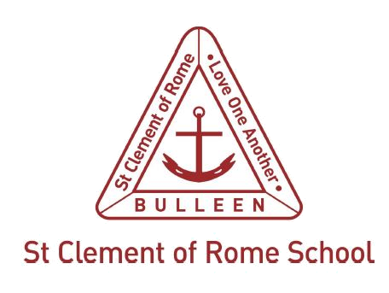

St Clement of Rome Catholic Primary School Photograph/Recording Permission Form

Dear Parent/Guardian
At certain times throughout the year, students may have the opportunity to be photographed or recorded/filmed by the school or its service providers for school publications, such as the school’s newsletter or website and social media, or to promote the school in newspapers and other media.
Melbourne Archdiocese Catholic Schools Ltd (MACS) and the Catholic Education Commission of Victoria Ltd (CECV) may also wish to use student photographs/recordings in print and online promotional, marketing, media and educational materials.
We would like permission to use your child’s photograph/recording for the above purposes. Please complete the permission form below and return it to the school as soon as possible. Thank you for your continued support.

NAME OF STUDENT | YEAR LEVEL

I give permission for my child’s:
☐ name
☐ photograph
☐ recording
to be published by the school on/in:
☐ the school website
☐ social media
☐ promotional materials
☐ newspapers and other media.
☐ I authorise MACS/the CECV to use the photograph/recording in material available free of charge to schools and education departments around Australia for MACS/the CECV’s promotional, marketing, media and educational purposes.
☐ I give permission for a photograph/recording of my child to be used by the school/MACS/the CECV in the agreed publications without acknowledgment, remuneration or compensation.
☐ I understand and agree that if I do not wish to consent to my child’s photograph/recording appearing in any or all of the publications above, or if I wish to withdraw this authorisation and consent, it is my responsibility to notify the school.
LICENSED UNDER NEALS: The photograph/recording may appear in material which will be available to schools and education departments around Australia under the National Educational Access Licence for Schools (NEALS), which is a licence between education departments of the various states and territories, allowing schools to use licensed material wholly and freely for educational purposes.

NAME OF PARENT / GUARDIAN / CARER (Please circle)

Signature | Date
If the student is aged 15+, they may also sign
Signature | Date
Any permission and consent given may be withdrawn by the parent/guardian or student (if they are aged 15 or over) by notifying the school in advance of any photograph or recording being made.
Disclaimer: Personal information will be held, used and disclosed in accordance with the school’s Privacy Collection Notice and Privacy Policy available on its website: www.clementbulleen.om

